

TabPlay

User Guide

Version 1.0.1

Table of Contents
Description and Features 3
What is TabPlay? 3
Features 4
Words of Warning 4
Technical Issues 5
Installation 7
IIS Installation 7
Configure and Test Network 8
TabPlay Installation 8
Installation of Microsoft Visual C++ Redistributable 9
Complete the Set-up 10
Setting Up Tablets 10
Upgrading TabPlay 10
Using TabPlay 11
Overview 11
Registration and Player Numbers 11
Bidding 12
Play 12
End of Board 13
End of Round 13
Troubleshooting 15
Network or Database Connection Problem 15
Correcting Player Names 15
Score Adjustments 15
Corrections and Errors Requiring Re-registration 15
Server or Wifi Connection Stops Working 16
Appendix 1 – TabPlay Workflow Diagram 17
Appendix 2 – Setting Up Dedicated Tablets 18

Description and Features

What is TabPlay?
In 2020, during the height of the Covid-19 lockdown, the Bedfordfordshire Bridge Association was thinking about how to manage the return to normal face-to-face bridge. Some of the issues were the proximity of players, and the handling of both cards and bidding boxes. They had seen the LoveBridge system which used tablets for bidding and play. This seemed to overcome these problems, but LoveBridge was clearly designed for tournament play and had a serious price tag to match. So they asked Peter Flippant, with his experience of developing the tablet-based wireless scoring application TabScore, if he could develop something similar to LoveBridge but for use at clubs and smaller events. The result is TabPlay.
TabPlay is primarily a web application that runs across a local wireless network. TabPlay requires a server (a PC or laptop computer running Windows 10), a wireless router, and some sort of table-top device with a browser (tablet, Kindle, phone, etc) for each player. Experience suggests that 10” tablets are ideal, but it is perfectly possible to play using smaller tablets or phones provided the players' eyesight is good enough. The idea was that each player would provide their own tablet device, to avoid handling by different people, but of course the club could keep a set of tablets for any players that don't have their own.
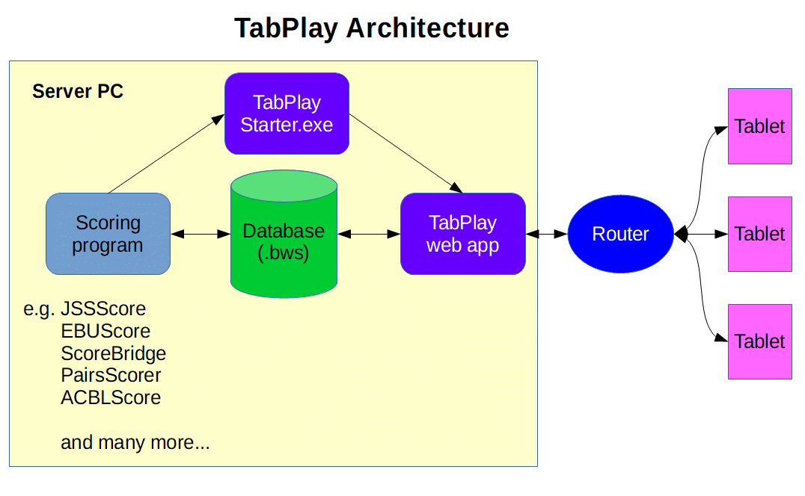
In designing TabPlay, an early decision was taken to use commonly available and cheap hardware and software, so that the system would be affordable and within the technical capabilities of most bridge clubs. This has placed some technical limitations on the use of the system (see the section on Technical Issues below), but it should nonetheless work well in normal club use. Other than a browser, no special software is needed on the tablets, although some customization of the tablets/browser will provide a better user experience. Again, see later in this Guide for more details.
TabPlay integrates with a traditional scoring program (such as EBUScore, ScoreBridge or BridgeScorer) which sits on the server. The interface is a Bridgemate .bws standard Access database, so TabPlay should work with any scoring software that can run Bridgemates. For full TabPlay funcionality, either EBUScore or JSSScore by Jeff Smith is recommended, and the latest version includes a 'TabScore' scoring option that can be used with TabPlay too.

Features
TabPlay can support virtually any type of event that can be set up using a scoring program. So it can be used to run pairs, teams and Swiss events; it can also be used for individual events with EBUScore. It is currently limited to 4 sections (A, B, C and D in that order) and 30 tables per section.
There are a limited range of options that can be set either via the scoring program or by using the Options button in TabPlayStarter. In particular, TabPlay offers the options to:
- Show the traveller at the end of each played board.
- Display the full hand records after the hand has been played. If this option is selected, TabPlay will use Bo Haglund's Double Dummy Solver (DDS) to analyse hand records, and display the makeable contracts.
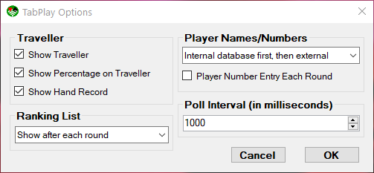
- Display the pairs or individual ranking list at the end of each round, or at the end of the event.
- Use either or both of an internal or external player names database. This is useful if your national bridge organization, like the EBU, provides a database of membership numbers.
If the tablet and browser support the functionality, TabScrore will display a battery level indicator (in the top left of the screen).

Words of Warning
TabPlay is not an 'out-of-the-box' solution. To get the system up and running, you will need to install and configure IIS, configure your network, install the software, set up the tablets, and integrate TabPlay with your existing scoring program. Doing all this requires some degree of IT competence. The good news is that, if you are already using TabScore, the process is very similar and a lot of the work will have already been done.

TabPlay comes with 2 Windows installer files (TabPlayIISSetup.msi and TabPlaySetup.msi) to make the installation and set-up process as automated and as straightforward as possible. But please make sure you read and understand the installation instructions thoroughly before proceeding.
The other issue to consider with using dedicated tablets is charging. The 7” tablets in use at Bedford Bridge Club will generally last 2 sessions of bridge between charging, and it is worth investing in good quality tablets to obtain a long battery life. We have adopted a system using battery packs. We charge up the battery packs during the bridge session, and then use the battery packs to re-charge the tablets overnight. This avoids the need to leave the tablets charging unattended on mains power. The picture shows the charging boxes we use with tablets and battery packs.

Technical Issues
TabPlay requires that changes made on one tablet (bids, cards played, etc) are reflected on the other tablets at the same table. A sophisticated web server (running for example Windows Server softare) would achieve this by maintaining open 2-way communication between the server and each tablet's web browser. As mentioned above, TabPlay has been designed to use cheap and widely available software, and for practical purposes this means Windows 10. Hence, TabPlay has been developed for a server PC running Windows 10 (which includes Internet Information Services (IIS) 10), .NET Framework 4.7.2 and ASP.NET 4.7.
Unfortunately, Windows 10 has a limit of 10 simultaneous open connections (concurrent HTTP requests), and IIS further restricts this number to 3. TabPlay circumvents these limitations by using a polling system. Each tablet periodically sends a polling message to the server opening a connection, and the server responds with any updates thereby closing the connection. The polling cycle is quick (typically a few milliseconds), but each poll needs an open connection and response times will degrade if the average number of open connections gets close to the limit of 3. With a larger number of tables, it would clearly help to have a faster and more powerful server to minimize the polling cycle time. In addition, there is an option within TabPlay to set the poll interval (in milliseconds). The default is 1000ms = 1 second, giving an average update time of just over 0.5 seconds that seems to be perfectly acceptable in practice. If you are experiencing performance degradation due to a large number of tables, increasing the poll interval option could help.
For table-top devices, TabPlay requires tablets, phones or other devices with an internet browser that supports Javascript (ie any mainstream browser). For an Android full-screen locked-down browser, Fully Kiosk Browser (https://www.ozerov.de/fully-kiosk-browser/) has been used successfully at Bedford Bridge Club.
TabPlay is written using C# and MVC, and the web pages use HTML5 and Bootstrap for formatting, and JavaScript/JQuery. The source code is available on GitHub.
Bo Haglund's DDS requires the Microsoft Visual C++ Redistributable 2015 (or later) to be installed on the PC.

Installation

IIS Installation
IIS provides the framework to run a web application on the server PC. It is a feature of Windows 10, but it is not installed by default. To install IIS and configure Windows Defender Firewall, either:
- Automatic Installation: Run the installer file TabPlayIISSetup.msi. If you have proprietary security software installed, please also see the section on Windows Defender Firewall.
- Manual Installation: Follow the steps below.
IMPORTANT: In either case, it will be necessary to restart the PC once this part of the installation is complete.
Manually Install IIS Features
To install the necessary IIS features on the server PC:
- Control Panel – Programs – Programs and Features - Turn Windows features on or off (requires Administrator privileges)
- Ensure that the following are selected:
  - .NET Framework 4.7 Advanced Services/ASP.NET 4.7
  - Internet Information Services
  - Internet Information Services/Web Management Tools/IIS Management Console
  - Internet Information Services/World Wide Web Services
  - Internet Information Services/World Wide Web Services/Application Development Features/ASP.NET 4.7
Manually Configure Windows Defender Firewall
You need to enable Port 80 on the server PC for incoming browser requests. If you have proprietary security software installed, then you may need to make the changes in that software. If using just Windows Defender Firewall, then:
- Control Panel – System and Security – Windows Defender Firewall
- Advanced settings (requires Administrator privileges)
- Inbound Rules – New Rule.
- Port, TCP, Specific Local Ports = 80
- Allow, Private
- Name the rule something meaningful (eg TabPlay Port 80) and Finish

Configure and Test Network
Configure Network
Various network configurations are possible, and this guide cannot consider all possibilities. The essential requirement is that the tablet browsers can consistently find the server PC across the router network. The simplest approach is to use a static IP address for the server PC, and the rest of this guide assumes this is the approch taken. An alternative would be to use a DNS server on your network, possibly in the router – if you choose this latter approach, we'll assume you know what you're doing!
A static IP address can often be set on the router:
- Log on to the router and set a DHCP device reservation (static IPv4 address) for the server PC. If there is no other network, an IP address something like 192.168.0.100 is probably suitable
- Setting a DHCP reservation may require the PC's physical MAC address. This can be found by opening a command prompt (cmd.exe) and typing 'ipconfig /all'
If your router does not support DHCP device registration (and many don't), you can go to the router network's settings via the PC's Control Panel, select Properties/Internet Protocol Version 4 (TCP/IPv4)/Properties and specify the IP address you require. When doing this, the default gateway is normally the IP address of the router, as is the preferred DNS server; setting 8.8.8.8 for the alternative DNS server usually works.
It is possible to have the server PC connected to the internet via one network and TabScore connected via another. This would require 2 networks cards (Wi-Fi or Ethernet). A configuration that has worked successfully at Bedford Bridge Club is internet on Wi-Fi (using subnet 192.168.0.xxx) and the TabScore router on Ethernet (using subnet 192.168.2.xxx and a static IP address of 192.168.2.100 for the PC).
Test Network Connection
Connect a tablet to the router network. This may require a password that is usually supplied with the router. Enter the IP address of the PC in the address bar (or default URL) in the tablet browser (so it should look something like http://192.168.0.100). If IIS is working correctly, the tablet browser should display the default IIS webpage.

TabPlay Installation
TabPlay comprises 2 main components: a web application that runs under the default IIS website; and a Windows executable (TabPlayStarter.exe) that is called by the main scoring program. Again it is possible to do either:
- Automatic Installation: Run the installer file TabPlaySetup.msi. This copies the necessary files and configures IIS to run the web application.
- Manual Installation: Follow the steps below.
Manually Copy Files
Copy files and folders to the following locations, creating folders if necessary:
- TabPlay folder to C:\Program Files (x86). This includes the WebApp subfolder.
- TabPlayDB.txt to C:\Users\Public\TabPlay
Manually Configure IIS
Open the Internet Information Services (IIS) Manager:
- Application Pools – Add Application Pool...
  - Name = TabPlayAppPool
  - Start application pool immediately
- TabPlayAppPool – Advanced Settings...
  - Enable 32-Bit Applications = True
- Sites – Default Web Site – Add Application...
  - Alias: = TabPlay
  - Application pool: = TabPlayAppPool
  - Physical path: C:\Program Files (x86)\TabPlay\WebApp
  - Start Website immediately

Installation of Microsoft Visual C++ Redistributable
Bo Haglund's DDS needs the Microsoft Visual C++ Redistributable (x86) 2015 (or later) to be installed on the PC. To check if this is already installed, go to Control Panel/Programs/Programs and Features, and see if it is listed as an installed program.
If necessary, search the Microsoft website for a suitable installer (it will have a name like vc_redist.x86.exe). Download this file, run it and follow the instructions.

Complete the Set-up
Test the TabPlay Web Application
Enter the IP address of the PC in address bar (or default URL) in the tablet browser, followed by /TabPlay (so the URL should look something like http://192.168.0.100/TabPlay). If IIS is working correctly, the tablet browser should display the TabPlay start screen.
Modify Scoring Program
The scoring program needs to start TabPlayStarter.exe as its wireless scoring software. How this is done varies considerably by scoring program.
In JSSScore and EBUScore (provided you have the latest versions), go to the Event menu for any event and then the Table Top Unit Scoring screen. This might be called something else if the program is currently configured for some other wireless scoring software. From here you can set the Table Top Unit to TabScore (or TabPlay if this is included in future versions) using the drop-down list. Then using the Admin tab and the Set TabScore Program Location button, set it to:
C:\Program Files(x86)\TabPlay\TabPlayStarter.exe
For other scoring programs, please see your scoring program documentation.

Setting Up Tablets
As mentioned previously, the tablets do not need any form of special configuration to run TabPlay – just a web browser. Each tablet's browser will need to point to the TabPlay URL. This URL is the IP address of the server PC followed by /TabPlay (so the URL should look something like http://192.168.0.100/TabPlay).
If using dedicated tablets, it makes sense to set the TabScore URL as the home page in the tablet's browser. In any case, it would be helpful to set a favourite that points to the TabScore URL. The dedicated tablets in use at Bedford Bridge Club have been set up with the Fully kiosk browser to run in full screen mode. The configuration of this and other tablet software used at Bedford Bridge Club is given in Appendix 2. However, the best way to set up your tablets will depend very much on the make and model of the tablets, and their operating system.

Upgrading TabPlay
When upgrading TabPlay to a new version, it is better not to do a full installation. Once you have downloaded the new installation zip file, all that is needed is to copy the TabPlay folder (which includes a WebApp subfolder) to C:\Program Files (x86), overwriting all the existing files and folders.

Using TabPlay

Overview
Compared to installing TabPlay, using it is pretty straightforward. The tablets will sit at the Start Screen until the event organizer has set the movement, created the scoring database, and launched TabPlayStarter.exe from the scoring program. See your scoring program documentation for how to do all this.
Once TabPlayStarter.exe has been launched, players will be able to enter their section (TabPlay defaults to Section A if there is only one section), table number and direction, enter their player ID numbers, and then proceed to bid and play each board for each round of the movement. A diagram showing the flow through the various TabPlay screens is at Appendix 2.

Registration and Player Numbers
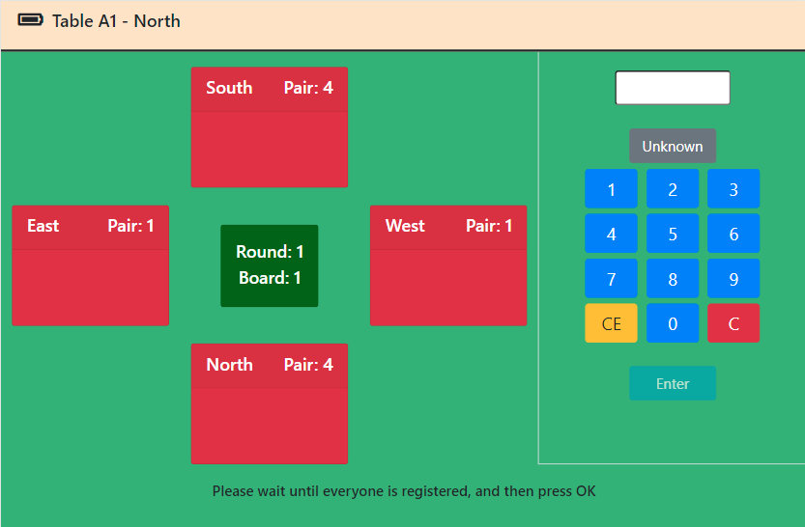
Player numbers and/or names can be set within the scoring program before creating the scoring database. However, it is normally easier to let the players enter their own player numbers into TabPlay at their tables. This is done on the Register Players screen, and each player enters their own player number using the keypad. Unregistered players are shown in red, and this will turn white when registered. Once all players at the table have been registered, North will be able to tap on the OK button to move to the bidding for the first board. The OK button is not visible in the screenshot as not all players have yet registered.
How TabPlay resolves player numbers to names is determined by an option that is set by the scoring program. Names can come from either an internal database of player names/numbers set up within the scoring program, or from an external database (as, for example, provided by your national bridge organization), or both. It is usual for numbers in the internal database to be in the range 1-9999 and for 10000+ for the external database.
If a player doesn't have or doesn't know their player number, TabPlay provides the option to enter Unknown (the grey button on the keypad). Internally, this sets a value of 0, so 0 should not be used as an actual player number. Names can be updated or corrected within the scoring program at any time. However, the scoring program needs to write the changes to the scoring database for the names to appear correctly in TabPlay.
If you are registering at a sit-out table, obviously only 2 players will need to register. In this case, when North (or East if North/South is the missing pair) taps the OK button, this will proceed straight to the Move or Ranking List screens as appropriate. See later for more information on these screens.
If you are playing a movement where not all players are seated at the start (eg a Rover or an Individual with an odd number of players), then the extra players will be able to enter their player numbers when they first sit at a numbered table (usually in Round 2). For some teams events, you may need to change player names during the course of the event. TabPlay can do this via an option set either in the scoring program or the TabPlayStarter Options button that allows player number entry each round.

Bidding
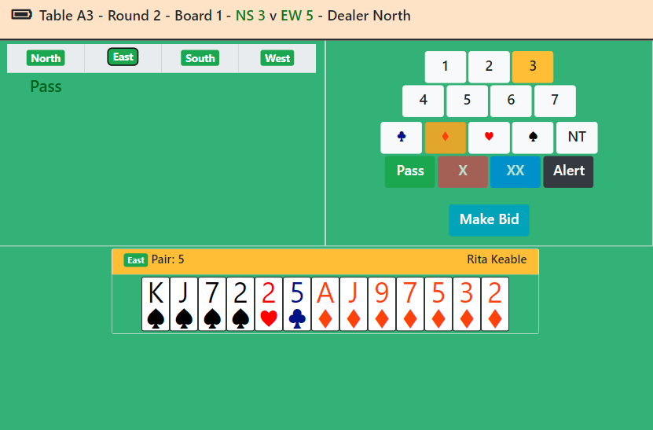
Once North taps on OK in the Register Players screen, all 4 players at the table will be taken to the Bidding screen. When it is a player's turn to bid, the 'bidding box' will be visible (as is shown in the screenshot). To make a bid, the player must select the bid and then tap on the Make Bid button; this is to prevent an inadvertant mis-tapped bid. Once the auction is complete, all players will automatically be moved to the Play screen.
It is up to individual clubs how they wish to implement alerting and announcing rules. Obviously, this can be done by simply speaking. However, TabPlay has an Alert button that allows players to self-alert bids in the style of Bridge Base Online. Any self-alerted bid will be highlighted to all the players with the exception of the alerter's partner.
To skip a board (ie not play the board in the current round), North must tap the Skip button that will be visible before the bidding commences. This can be used if the Tournament Director removes a board from play, or if an incomplete round is specified in the movement. Once the first bid has been made, however, it is no longer possible to skip the board.

Play
The play screen allows players to play cards in the usual manner. A card is played by tapping on the card symbol, thereby highlighting it, and then tapping on the Make Play button. As in the Bidding screen, this procedure is designed to prevent inadvertant misplays.
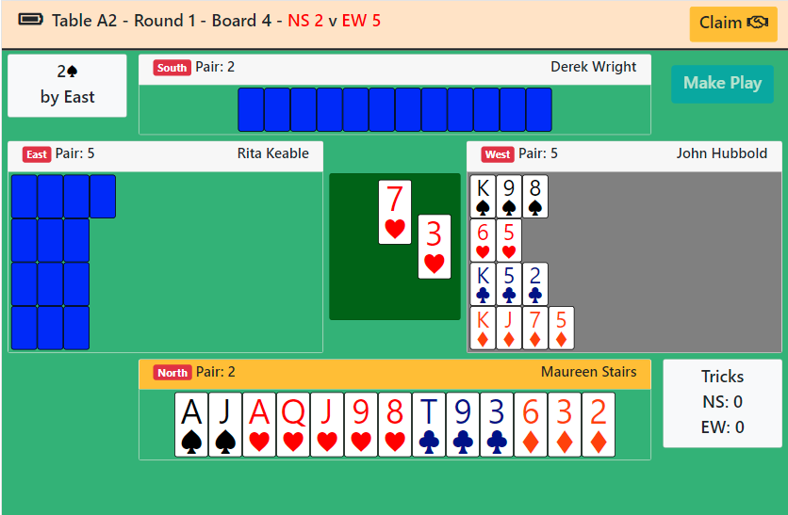
The only exception is the opening lead. The first tap of the Make Play button will play the card but not expose it. This allows the other defender to ask questions of the bidding without compromising the lead. Tapping the Make Play button again will expose the lead and also expose dummy's cards. Dummy's hand is shown with a grey background and, of course, it is up to declarer to play cards from dummy's hand. Dummy will be able to observe but not take part in the play, as normal.
At any time during the play, any player can make a claim. Tapping the Claim button allows a player to expose their cards so that the claim can be explained to the opponents. At this point, if the players decide to do so, play can continue. However, if the claim is agreed, North can tap the Claim button again to enter the agreed total number of tricks taken by declarer.

End of Board
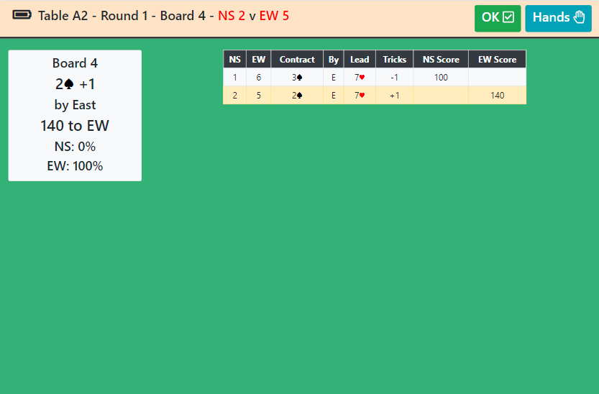
Once the board is finished, either by playing all the cards or by making an agreed claim, all 4 players at the table will be shown the Traveller screen. This displays the result, the percentage for the board, and the results at other tables. There is also a Hands button that alows players to view the full hand records and makeable contracts (TabPlay uses Bo Haglund's double dummy solver to do the analysis). It is possible to set TabPlay options to disable the display of hand records, percentages, or to omit the display of the Traveller screen entirely.
If there is another board to play in the current round, tapping the Traveller screen OK button (or if the Traveller screen is omitted) takes the player back to the Registration screen. Once all 4 players have reached the Registration screen, North can tap OK again to proceed to the bidding and play for the next board.

End of Round
TabPlay provides the option to view a ranking list based on matchpoints, either at the end of each round or at the end of the event. Obviously this is only useful for pairs and individual events, and it is recommended that this option not be used for teams or Swiss events. For pairs, EBUScore populates a database table with the ranking list data; TabPlay uses this and so will show exactly the same ranking list that EBUScore does. If the ranking list data is not available, TabPlay will make an attempt to calculate rankings based on a simple matchpoint calculation. This ranking list may therefore differ slightly from the one shown by your scoring programme if Neuberg or some alternative scoring method is being used; it is nonetheless a useful guide to players during the event. The ranking list will automatically refresh every 10 seconds.
Between rounds TabPlay, will display the movement information for each player. It is not possible to proceed beyond the Move screen until the table you are trying to move to is completely ready to play – ie all players at that new table are at their own Move screens. Once players have moved to the new table and have tapped on the Move screen OK button, they will be taken to the Registration screen for the new table.
Once the event is over, or the round is over for Swiss events, TabPlay will display an End screen. This encourages the players to switch off the tablet, but the tablet can safely be switched off before reaching the End screen as all the data is stored on the server PC. As the screen explains, for Swiss events, once the draw for the next round has been made and the movement information is available, tapping the End screen OK button will bring up the movement for the next round.

Troubleshooting
Things can go wrong, either as a result of user error or a problem with the server PC or network connection. The thing to remember is that all the data is stored on the PC, and TabPlay merely shows a view of that data. So, as long as the server PC is still working, no data will be lost. Thus, for example, it is always possible to resume a previously aborted session simply by loading an existing database into the scoring program and launching TabPlay. Likewise, it is easy to replace a tablet (if the battery runs out, for example), just by re-registering with a new tablet.

Network or Database Connection Problem
TabPlay attempts to detect if there is any problem with the network or database connection for any one tablet. If this happens, TabPlay will show an Error screen, and it will prompt the player to re-register (at the current section, table and direction). Usually such problems are rare and temporary, re-registering will resolve the issue.
If you have already registered, you will get a warning; however, if you are simply re-registering, it is safe to proceed. Re-registering will take you to the current situation for that table/direction, so you might resume in the middle of bidding or play.

Correcting Player Names
If the player makes an error when entering their player number, it can be changed at the initial Registration screen. However, once the bidding has started, any name corrections will need to be done via the scoring program. Be aware that some scoring programs do not automatically update the scoring database with name information, so any changes may not show in TabPlay. In particular, in EBUScore you will need to use the Write Names button on the TabScore/TabPlay Scoring screen to update any name changes to the database. Please see the documentation for your own particular scoring program.

Score Adjustments
There is no facility to enter adjusted scores within TabPlay. Any scores that are adjusted by the Tournament Director will need to be entered at the scoring program. However, be aware that some scoring programs do not automatically update the scoring database by default, so these adjustments may not show correctly on the Traveller screen. Please see the documentation for your own particular scoring program.

Corrections and Errors Requiring Re-registration
There are a few user input errors that cannot be corrected using the software, for example entering the wrong section or registering at the wrong table or direction. These issues can generally be resolved by returning the tablet or tablets to the TabPlay Start Screen, and then re-registering.
The procedure for getting to the Start Screen will depend on the browser. There may, for example, be a Home button. For the full-screen version of the Fully Kiosk browser, the procedure is usually to swipe right to get to the menu, and then tap on Goto Start URL.

Server or Wifi Connection Stops Working
The server PC or Wifi router may stop working for some reason. A common example is when a laptop left running on battery power decides to shut itself down. If this happens, the tablets may freeze. Once you have resolved the problem with the server/router and re-started, the tablets may just continue working. If not, it may be necessary to re-register all the tablets.

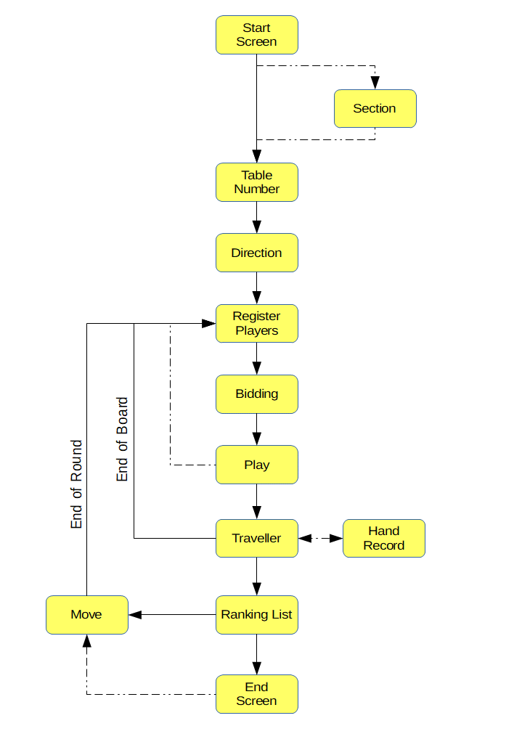
Appendix 1 – TabPlay Workflow Diagram
Main Flow
Optional Flow

Appendix 2 – Setting Up Dedicated Tablets
Bedford Bridge Club uses dedicated tablets with the following software: Fully-Kiosk-Browser-v1.28.1; Nova Launcher_v5.5.4 and Icon Changer_v2.0.
This has been configured as follows:
- Set Nova Laucher as the default start app.
- Set the following settings in Nova Launcher:
  - Desktop/Desktop grid 4x4
  - Desktop/Icon size/Font size = about 75%
  - Desktop/Wallpaper scrolling off
  - App & widget drawers/Frequently used apps off
  - Dock/Enable off
  - Look & feel/Normalize icon size off
  - Look & feel/Screen orientation Force Landscape
  - Look & feel/Show notification bar off
- Using Icon Changer, set the Fully icon to TabPlay.png (included in zip file) and set label to TabPlay.
- Delete all icons from desktop except TabPlay
- Set wallpaper to something suitable. Bedford Bridge Club has created it's own wallpaper.
- Set Fully start URL to static IP address of laptop + /TabPlay
- Set Fully/Web Zoom and Scaling/Set Font Size = 150% (or whatever best suits your device).
It is possible to use the Fully setting Device Management/Launch on Boot to start Fully automatically when the tablet is switched on. However, we have chosen not to do that.

